This is a HTML 5 canvas

In this lesson we will be covering html 5 Canvas

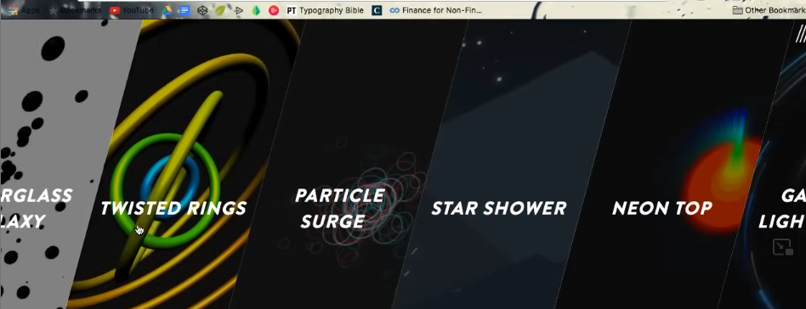

You may have come across a site in your lifetime where you notice that it poses some kind of cool stylistic background



When you hover over these background then you will notice that background is actually interacting with your mouse based on your mouse position and this may have taken you back a bit you may have

been like whoa this is actually pretty cool I did not even this sort of stuff was possible on the web.

And this kind of stuff it takes you by surprise its intriguing pulls you in a website it gives a unique feel that makes you stand out from the rest If you are thinking to yourself that we would like for my site to have unique impression or I just like to know how to create kickass visuals cuz its really good then this is going to be the perfect course for you we are going to be covering what these peice called HTML 5 Canvas There are other tutorial that teaches about it but they will tall you that much in advance they will cover jus aspect such as drawing on the canvas animating on the canvas but they don’t really put everything together as a whole that’s what teacher like to fix with this course. To show us how to put all main base pieces of canvas together to create a very realistic interesting pieces as a result

Now html canvas is just an HTML element as soon we enter it in our HTML and apply border on it then you can see it Now our cide like look like below

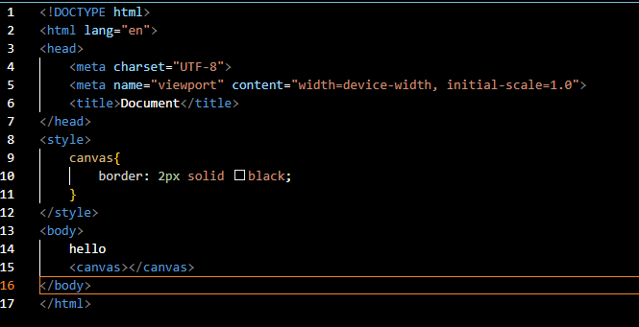

Now out put will look like below

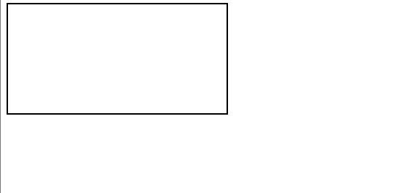

Now we see above that canvas is created for us in which we can then draw on and manipulate the pieces within it so lets start off with the basics to create any good looking canvas piece you are going to need to know four essential skills

1. you need to how to create a canvas first off and then you need to know how to resize it depending on the projects requirement
2. you need to know how to draw element on the screen there are a lot of elements you can draw but we need to know what kind of element we can draw in the first place and how do we do it.
3. We need to know How to animate these elements skill 2 will only take us so far because we are drawing static artwork on a screen but we want to make this artwork more interesting so we need to know how to move element from one location to another location and make it smooth transition in the process
4. We need to know how to interact with this element whether it be a mouse move and mouseDown , a mouse click or maybe even the touch on the screen or even a tilt on your phone we need to know how we can get the canvas to interact with any of these listener that we have at hand
5. So these are the essential skills you need for any HTML canvas piece once you know this skill you are going to create a badass visuals on the web you are going to pull people on your screen and people are going to be amazed with your work

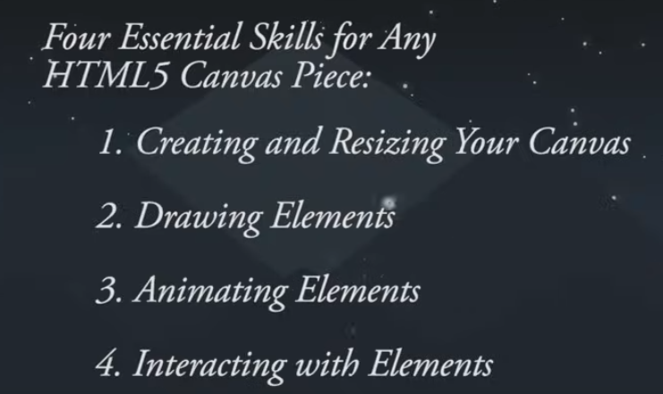

So now lets get started with skill 1 that is creating and resizing your canvas

Now we are going to be covering step number one of becoming a canvas pro that is creating and resizing your canvas

Its very important to know how to do this from start because first we are going to know how to create a canvas and then second we know how to resize it based on your project needs not all project are going to be of the same width and height do we need to make sure we know how to resize this canvas So make a separate folder to store these files I name It canvas-projects an then inside to organize this project we make a folder named as canvas-resize. Now we have this we need files that we are going to use to create our canvas piece and we need two files we need an html file and then we need javascript file so we create it inside the canvas-react folder Techer is using Sublime but I am using VSCode so we name our html file index.html and name out js file as canvas.js. So we now have the two basic files we need for pretty much any canvas piece

4:15

You can do a lot woth these two files Now we go to our index.html and then add some html boiler plate which we are going to need for pretty much any canvas piece

Now we create boiler plate in vs studio

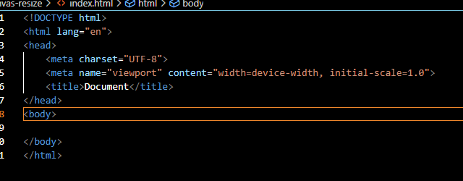

Now we have boilerplate as shown above

Now we add the title that is Canvas-Resize

And then add H1 tag in out body tag and then inside add a dummy tag we add Hello world there

We are adding this because we want to make sure we can test it out in the browser and browser can read it

Now code look like below

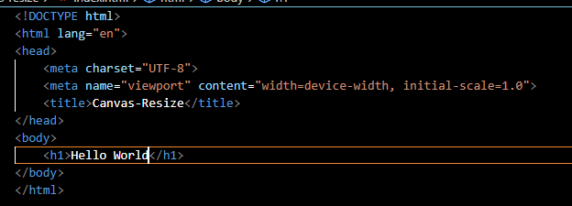

Now its output is as shown below

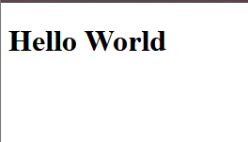

Now you can see it is read by the browser

But this is not an HTML tutorial it is a canvas tutorial so we are not going to deal with h1 element not a the moment at least we want to deal with what’s known as canvas element

Now we remove h1 and add canvas element which don’t have text inside it

Now we save our file and see the output you will see a blank screen as shown below

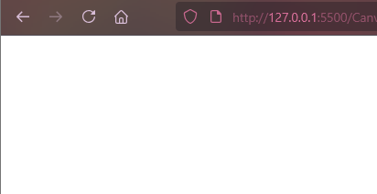

But the canvas is still inserted on the screen you will see that if I inspect our browser

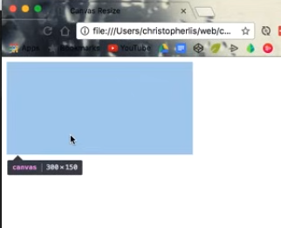

We will see that canvas is there but it is hidden and you can see it highlighted when you hover over the canvas element and then it get highlighted. It is hidden because we are blending with the background and out canvas and background are by default white so its just basically just blending there but we want to make sure that we can see it without having to inspect our actual canvas so in order to that we are going to add some style tag in our Head tag

In style element we choose canvas and then set border of 1px solid and black and save the file as our website is love in localhost because of VS Studio we see the change immediately. Our code is as shown below

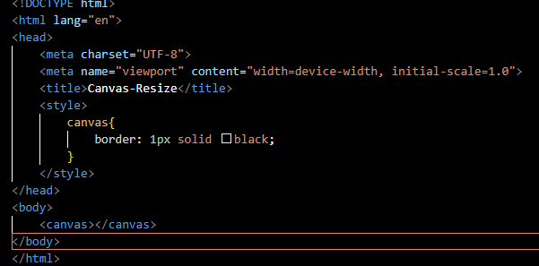

Now the output will be like below

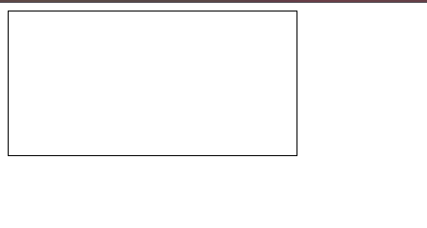

So now our canvas is visible because of border now this is the place where we can draw shapes and animate shapes and later interact with them only within this are enclosed by border we cannot interact part outside of canvas so we want to make sure that his canvas expands entire width and height of the screen well how do we do that you may be thinking that weel can’t we just add some css that give it height to 100 % and then width to 100 percent let see what will happen we do that

Now you can see below that width is somewhat 100% but there is space because of body default margin but height is not increased to 100 percent that’s because html tag of interior document 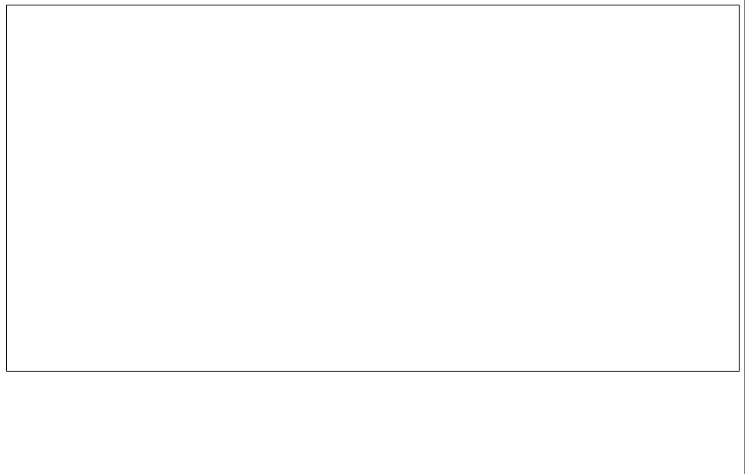

does not actually take up the full height of the screen I think when the canvas itself not strwetch it to full height may it is its characteristic (who knows)

So to solve this we are not going to set out height and width through CSS we are actually set out height and width through our js file , Through js file we can ensure that the height and wodht of the canvas will always be the entire height and width of this full width browser width we can make sure the canvas is taking up the entire screen so we go to canvas .js but first we need ot make sure that or HTML file is reading code from canvas.js

So to test it we write console.log() to write dummy text. The text can be anything you want

Suppose we write text that is Heelo wprld now you cannot see anything in console

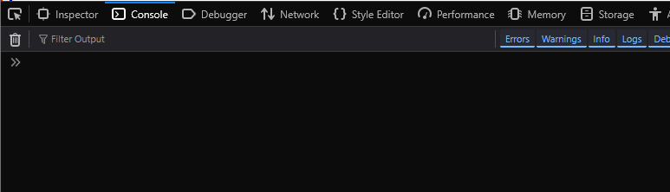

This is because our HTML file is not reading our script in console.js

8:10

We want to make sure that index.html is reading whatever id here within canvas.js So in order to do that we are going to add a script tag right above the closing tag of canvas and after tags of canvas Now we make the index.html read the canvas.js with the help of script tag and we have a src attribute in which stores the address of canvas.js file by referencing through relative referencing

Now you save your file and then browser will be refreshed

And now in your console you can see the message Hello world

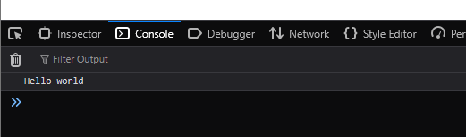

So now connect the index.html and canvas.js Now we can get to manipulate our canvas But how do we do it . Well the first thing we are going to create a variable called canvas in canvas.js as shown below



and we want to be able to select HTML element and put it within this canvas js variable So how do we do that with js well we want to first select a document object and then we say query selector and then in its argument pass the kind of element we want to grab so we want to grab an HTML tag called canvas(AI says that it just get the first occurrence of the element if there are multiple element) and add semicolon at the end of the semicolon(not mandatory). Now our code will look as shown below



So what’s happening right here is that we are going to be searching our entire html document and we are going to be looking for an HTML element of canvas so its going to search all this and once it hits canvas it going to place that right inside our canvas variable or we say an object will be returned representing our canvas element in our html. We can test it is working by console logging out the canvas as marked below.

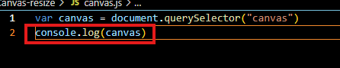

Now in console you can see 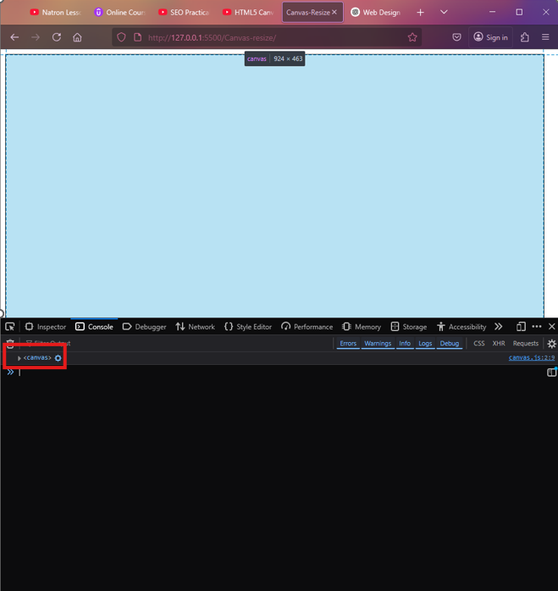

Our element is shown in the console no when you hover over this then the canvas will be highlighted as shown above

It means our canvas is successfully placed within this canvas variable in our js file

9:50

So now we need to alter the width and height of the canvas how do we do that we

Now through canvas variable and now it has object representing the canvas we will access width parameter to change its width programmatically and then assign it browser width that is window.innerWidth as shown below

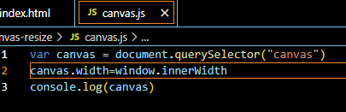

and since there is default left, bottom and top margin in the browser there will be gap in the top and left as shown below

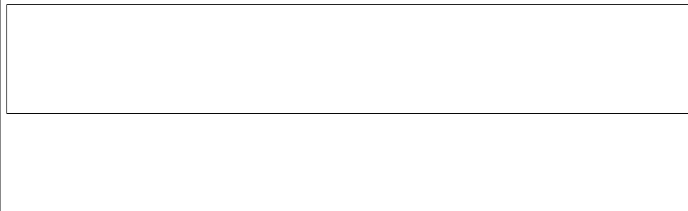

So what’s happening that here is grabbing the window’s inner width and inner id from left to right edge of the browser(I think excluding the ) and we are setting canvas width equal to that Now we are setting it width we also need to set our canvas height it is not going to be equal to the window.innerWidth but the window.innerHeight as shown below

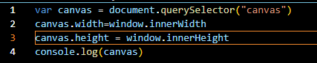

Now the output will be look like below



But there is still a little issue here we have this little bit of margin in the top and on the left now what’s up with that well by default some elements have some default styles applied to it.

If we go ahead and inspect out body then we will see in its style that there is margin of 8px by default as marked below( I don’t know why I can only see it in Chrome but not in firefox )

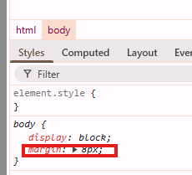

Now we want to make sure that this is not there so we are gonna head to the style section in our index.js

Now in our css we are going to select our body and set its margin to 0 as shown below

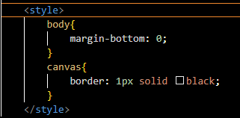

And bow with this we have a canvas taking up the full width and height of the screen without any issues we can text it by adding background color red to the canvas

Now our ccanvas selector wil look like below

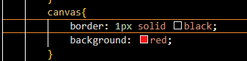

Now our output like below



Now you can see red is taking our entire screen but there is still some bottom margin (I don’t know)

Alright now we know how to create a canvas and we also know how to resize it so that it takes up the entire width and height of the screen but there is a lot of more that goes in this obviously we want to draw

11:28

on this canvas that’s what skill number 2 we are learning. How to create all the different object canvas possesses so we can get to drawing squares, circles and other shapes you can draw uh link characters(who knows) that was one of the first Teacher project was creating a drawing of a character from the wind Waker (may be a movie or cartoon series ) which Bezier curves , lines and colours with canvas so there is ton that we can draw here but let’s go ahead and get started with just drawing a simple box that’s going to be the first step and Teacher don’t want to leave you hanging without drawing on this canvas so we are going to head over our javascript file we are going top create a new variable called c and this c variable stand for something called a context we are just going to shorten it for c because we are going to use this variable so very often it’s take long time to type context out over and over again just so within just know that c within canvas is always going to stand for context so we will assign c that is canvas.getContext(‘2d’) and this will return a context object (maybe telling the thing which are going to do in canvas and we are telling we are going to 2D work through this c variable ) Now code will look like below

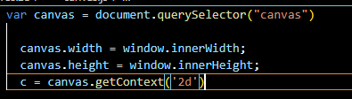

So what’s going on here well basically in technical terms, what’s happening is we are returning a drawing context to a variable called c but that can be a little confusing what teacher want us to think that within c we are going to creating a super object where we are basically passing a ton of methods and functions in which we can actually draw within our canvas. Think of it has magic paint brush to draw circles, squares and so forth only within 2D space we can’t draw like spheres or boxes or anything like that but we can draw out 2D elements that can be manipulated within a 2D space So now we do that we have all the access to all these methods and functions which we can draw on the screen this variable called c. So first function teacher going to share with us is called fillRect and it takes four argument x value, y value and width and height so it is pretty self-explanatory. X and y are going to determine where on the screen this rectangle is going to be and width and height is going to determine obviously the width and height of the rectangle so now we give it x coordinate of 100 and y coordinate 100 and this is to be relative from the top left screen of the coordinate system ( I think canvas top-left ) so this is going to be the rectangle that’s 100 pixel from the left of the screen and 100 pixel from the top of the screen and now we need to specify width and height to 100. Now our code will look like below

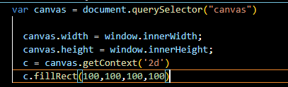

Now when we save our file due to which when browser is refreshed and then we see screen like below

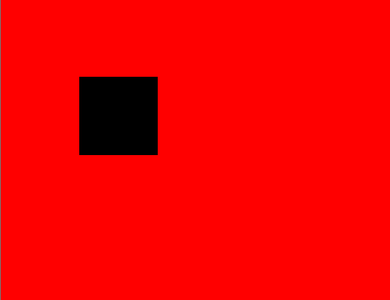

I make the background again white by removing the background property in the styles Now it will look like below



13:55

Now we have a box being displayed we are actually drawing on the screen and we can create multiple boxes in different location if we would like as shown below

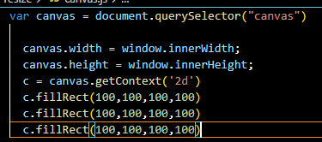

Now if we manipulate the coordinates in the second and third fillRect as marked below

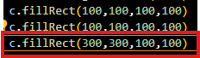

Now our output will look like below(the first drawn square is hidden behind second as second was drawn later )

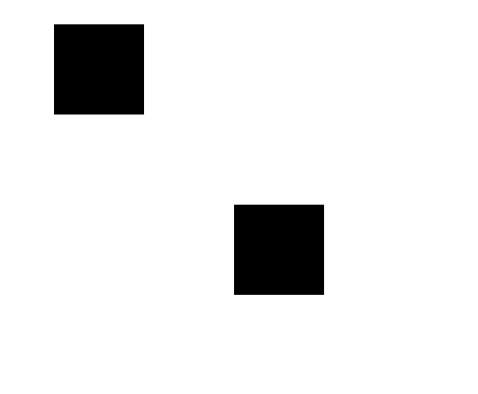

This time we change the coordinates of the second square as marked below

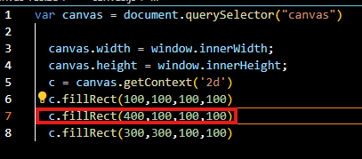

Now the output will look like below

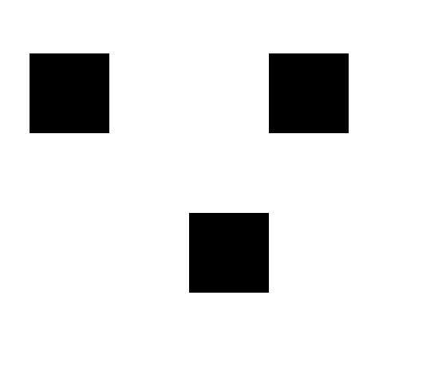

Teacher want us to play around with this It is pretty fun even if it is just drawing simple boxes because eventually we are going to be manipulating this we are going to be animating them. We are going to have them bounce off walls and so forth but this is going to be the first time we first need to be able to draw the actual objects on the screen so that’s going to be for this We successfully learned how to create a canvas how to resize it based on our screen and next we are going to cover all the different objects that we can draw on it using our magic c variable in our script. So see you in the next lesson.